(Title usually falls within 3 lines. All lexical words, as well as prepositions over 5 letters(including 5) should be initials in capital.)

Effects of Reynolds Number on the Efficiency of Highly-loaded Multi-stage Axial Compressors

(Author affiliations should be listed according to the name order under the paper title. Chinese authors should put the family name first. The corresponding author should be marked with “*” on the top right. Co-first-author is not allowed.)
ZXX LX^{1,*}, JXX SXX^{b}
ªDepartment of Aerodynamics, Nanjing Aeronautical Institute, Nanjing 210016, China
^{b}School of Electronic and Information Engineering, Duke University, Durham NC 27708, USA

AbstrThe effects of Reynolds number on the compressor efficiency are investigated by tests on three highly-loaded 10-stage axial compressors.The tests are conducted by adjusting the inlet total pressure， and thus different Reynolds numbers are obtained.The results indicate that the compressor efficiency decreases when the Reynolds number decreases.Based on the test results， reasonable correlations between the Reynolds number and compressor efficiency for each of the three compressors are obtained.The comparison between the test result-deduced correlations and Wassell correlations indicates that the effects of Reynolds number on the efficiency predicted by the Wassell correlations are less than those obtained by the test result-deduced correlations.Owing to the complex loss models and flow behavior in highly-loaded multi-stage compressors， additional influence factors， including the tip clearance and the compressor inlet duct design， should be considered for performance correlations.Nevertheless， the Wassell correlations are valid for the tendency prediction of performance changes relating to the Reynolds number， while accurate correlations still largely depend on the specific test results.（Abstract should be about 150-200 words which can conclude the whole content of the paper (including purpose, method, results and conclusion). Equations, figures and tables, as well as references are not supposed to appear in this part. When abbreviation is firstly used, it should contain the full name with its abbreviation included in parentheses, such as “signal to noise ratio (SNR)”. Do NOT use the first person as subject. Do NOT repeat the title as the first sentence of the abstract. Simple sentence and active voice are preferred, and verb should be close to the subject.)

Keywords: Transonic flow; Unsteady flow; Full-potential equation; Assembly;flight delays (about 5-8 words separated with “;”; use small letters except technical terms. Abbreviations should contain full name with abbreviation included in parentheses. Selection of 1-2 from EI controlled term list is preferred:
Received date：20XX‑XX‑XX； Revised date：20XX‑XX‑XX
*Corresponding author. E-mail address:abc@buaa.edu.cn

1. Introduction
(Begin each paragraph with an equal indentation of two typing spaces.)
The computation method of unsteady transonic flow based on N-S equations should be best accurate, but to three-dimensional complex problems, it can be achieved
only on large computers, and moreover, the resultsare not ideal sometimes. ^{[1]} A viscous/inviscid interaction method is an applicable one and the computation time can be reduced by two orders.
(Equations, figures and tables are usually not supposed to appear in this part.)
2. Computation scheme
2.1. Governing equation
2.1.1. Principle
The unsteady full-potential equation written in a body fitted coordinate system is given by
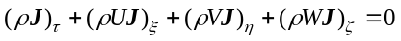 (1)
where ρ is density,U, V, and W are the contravariant velocity components in the ξ, η, and ζ directions,means time, and Jis Jacobian.
Eq.(1) is solved by the time-accurate approximate factorization algorithm and internal Newton iterations; ² body conditions and wake conditions are implicit embedded.
2.2. Generation of grids
Taking the incompressible potential flow round a cylinder for example, the stream function is
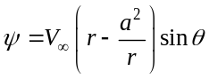 (2)
where ais radius, and 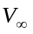the velocity of free stream. Magnifying its radius to .
3. Presentation of results
3.1.Artwork/Figure
Regardless of the application used, when your electronic artwork is finalised, please "save as" or c-onvert the images to one of the following formats (note the resolution requirements for line drawings, halftones, and line/halftone combinations given below):
EPS: Vector drawings. Embed the font or save the text as "graphics".
TIFF: color or grayscale photographs (halftones): always use a minimum of 300 dpi.
TIFF: Bitmapped line drawings: use a minimum of 1000 dpi.
TIFF: Combinations bitmapped line/half-tone(color or grayscale): a minimum of 500 dpi is required.
Size
Half column figure width should not exceed 7.5 cm.
Full column figure width should not exceed 15 cm.

Text font and Unit format
Text font in the figure should be in New Roman (the size should be 7.5 pt).
Unit format should use parentheses, such as Speed(m/s) and Pressure(MPa).
If your electronic artwork is created in a Microsoft Office application (Word, PowerPoint, Excel) then please supply "as is".
Please do not:
• Supply files that are optimised for screen use(like GIF, BMP, PICT, WPG); the resolution is too lo-w;
• Supply files that are too low in resolution;
• Submit graphics that are disproportionately large for the content.
Color artwork
Please make sure that artwork files are in an acceptable format (TIFF, EPS or MS Office files) and with the correct resolution. If, together with your accepted article, you submit usable color figures then Elsevier will ensure, at no additional charge, that these figures will appear in color on the Web (e.g., ScienceDirect and other sites) regardless of whether or not these illustrations are reproduced in color in the printed version.
Please ensure that all copyright permissions for figures and tables included in your manuscript have been properly obtained. This includes any figures, tables, or images reproduced or adapted from previously published sources such as journal articles, dissertations, websites, reports, or your own prior work. All such materials must be appropriately cited and accompanied by documented permission from the original copyright holders, where required.
For any use of maps, the latest version of standard maps must be strictly adopted, such as those from the Standard Map Service System of the Ministry of Natural Resources of China (Website: http://bzdt.ch.mnr.gov.cn/) and the corresponding valid map review number shall be provided. The use of maps of unknown origin or outdated versions is prohibited. In case of self-created maps, they shall be submitted to the review of the official website http://bzdt.ch.mnr.gov.cn/ and the corresponding valid map review number shall be provided.
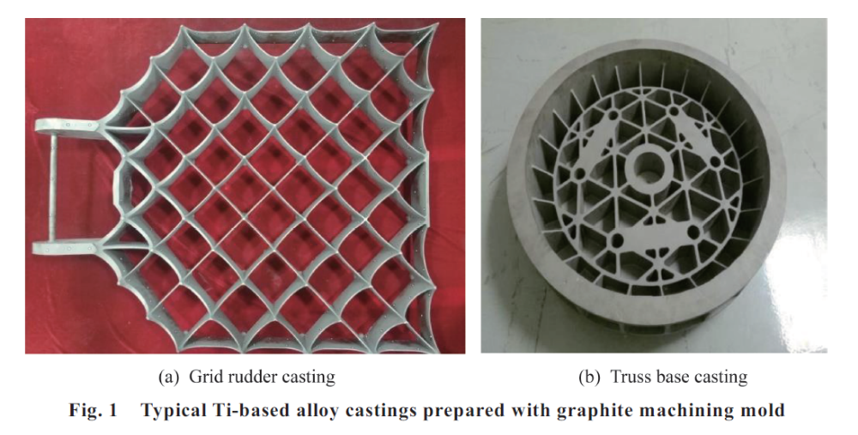

Table 1 CPU time ratio of each term.
Computational term | CPU time (%)
Flow field | 32.6
Solid temperature field | 2.2
Species concentration field | 4.3
Radiation transfer/energy field | 60.9

4.Conclusions
(Conclusion should be summarized in points without tedious description of background, method, etc.)
(1) A rapid method of the generation of boundary-fitted dynamic grids is developed in this paper, and the method of Viscous/Inviscid Interaction is used to compute the unsteady aerodynamic forces on wing/missiles and wing/body with control surfaces.
(2) The computation results are in agreement with experimental data.
References
Generally, the number of an article should be more than 35 referencesIt is advisable to cite the latest and most important references, and avoid referring to outdated or unnecessary ones.

Text: Indicate references by superscript numbers in the text. The actual authors can be referred to, but the reference number(s) must always be given.
List: Number the references in the list in the order in which they appear in the text.
Examples:

Reference to a journal publication (Journal names should be abbreviated, but if you are uncertain, keep it in full name)
[1] Van der Geer J, Hanraads JAJ, Lupton RA , et al. The art of writing a scientific article. J Sci Commun2000;163(1):51–9.
Reference to a book
[2] Strunk Jr W, White EB. The elements of style. 3rd ed. New York: Macmillan; 1979. p. 5-10.
Reference to a chapter in an edited book
[3] Mettam GR, Adams LB. How to prepare an electronic version of your article. In: Jones BS, Smith RZ, editors. Introduction to the electronic age. New York: E- Publishing Inc.; 1999. p. 281–304.
Conference paper
Christensen S, Oppacher F. An analysis of Koza's computational effort statistic for genetic programming. EuroGP 2002: Proceedings of the 5th European conference on genetic programming. 2002.
Scientific or technical report
Russell ML, Goth-Goldstein R, Apte MG, et al. Method for measuring the size distribution of airborne Rhinovirus. Berkeley (CA): Lawrence Berkeley National Laboratory, Environmental Energy Technologies Division; 2002. Report No.: LBNL49574.
Dissertation
Borkowski MM. Infant sleep and feeding: a telephone survey of Hispanic Americans [dissertation]. Mount Pleasant (MI): Central Michigan University; 2002.
Patent
Pagedas AC, inventor; Ancel Surgical R&D Inc., assignee. Flexible endoscopic grasping and cutting device and positioning tool assembly. United States patent US 20020103498. 2002 Aug 1.
Journal article on the Internet
Abood S. Quality improvement initiative in nursing homes: the ANA acts in an advisory role. Am J Nurs [Internet]. 2002 Jun [cited 2002 Aug 12];102(6): 51-9. Available from: http://www.nursingworld.org/AJN/2002/june/Wawatch.htmArticle
Article not in English
Liu JY. An improved SST turbulence model for hypersonic flows.Acta Aeronautica et Astronautica Sinica 2012;33(12):2192-201 [Chinese].
Homepage/Web site
Cancer-Pain.org [EB/OL]. New York: Association of Cancer Online Resources, Inc.; c2000-01 [updated date] (cited date). Available from: http://www.cancer-pain.org/

